# **Wigner Monte Carlo Approach to Neutrino Oscillation**

## **M.K. Chowdhury1, S. S. Pranta1, S.N. Reza1, S. Ahmed1, Dr. Md. E. Hoque1**

# *1Department of Physics, Shahjalal University of Science & Technology, Bangladesh*

Email: [mjonyh@gmail.com](mailto:mjonyh@gmail.com)

**Abstract**

Neutrino flavor is considered as a mixed state of mass eigenstates $(ν_{a}, a=1, 2, 3)$ which are governed by time-dependent Schrodinger Equation (TDSE). Thus, the evolution of an initial neutrino flavour can be determined by solving TDSE. In this work Sellier's generalization of Wigner Monte Carlo (based on signed particle formulation) is used to evaluate the real time evolution of the mixed flavor state to show the flavor change phenomenon and thus neutrino oscillation.

**Introduction**

Three known neutrinos $ν_{e}, ν_{μ}, ν_{τ}$ are massless in the standard model (SM) as a straightforward consequence of its simple structure and renormalizability. On one hand, the SM does not contain any right-handed neutrinos, and thus there is no way to write out the Dirac neutrino mass term. On the other hand, the SM conserves the $SU{\left(2\right)}_{L}$ gauge symmetry and only contains the Higgs doublet, and thus the Majorana mass term is forbidden. Although the SM possesses the (B-L) symmetry and naturally allows neutrinos to be mass less, the vanishing of neutrino masses in the SM is not guaranteed by any fundamental symmetry or conservation law. (1) There exists a lot of evidence for neutrino oscillations from solar, atmospheric, reactor and accelerator neutrino experiments. (2) (3) (4) The phenomenon of neutrino oscillations implies that at least two neutrinos must be massive and three neutrino flavors must be mixed. This is the first convincing evidence for new physics beyond the SM. (1) (5)

The fact that neutrinos have masses means that there is a spectrum of neutrino mass eigenstates $(ν_{a}, a=1, 2, 3)$ each with a mass $m_{a}$. Leptonic mixing implies that in a decay process (i.e. $W^{+}→υ_{a}+\overline{l_{α}}$; here $α=e,μ or τ$ and $l_{e}$ is electron, $l_{μ}$ is muon, $l_{τ}$ is tao) the flavor neutrino eigenstates is accompanied by the neutrino mass eigenstates which is not always the same $ν_{a}$, but can be any of the normalized combination of $ν_{a}$. The

amplitude for $W^{+}$ decay to produce the specific combination $υ_{i}+\overline{l_{α}}$ is denoted by $U_{αa}^{*}$. The neutrino state emitted in $W^{+}$ decay together with the particular charged lepton $l_{α}$ is then

$$\left.|ν_{α}\right\rangle =\sum_{a}{U_{αa}\left.|ν_{a}\right\rangle }$$

# This superposition of mass eigenstates is called the neutrino of flavor $α$. (6) The mass eigenstates $ν_{a}$ can be regarded as a quantum particle with definite mass $m_{a}$ governed by Schrodinger equation rather than the Dirac equation considering relativistic effects.

# **Theory**

Neutrino oscillation refers to transition between different flavor neutrino $(ν_{e}, ν_{μ}, ν_{τ})$. The time dependent mass eigenstates are governed by Schrodinger equation.

|  |  |  |
| --- | --- | --- |
|  |  | (1) |

Taking $ℏ=1$ and H is the total Hamiltonian of form

|  |  |  |
| --- | --- | --- |
|  | $$H=\left(p+\frac{\sum{m_{i}}}{4p}\right)I+\left(\begin{matrix}{m_{1}}^{2}-{m_{2}}^{2}-{m_{3}}^{2} & 0 & 0 \\ 0 & {m_{2}}^{2}-{m_{3}}^{2}-{m_{1}}^{2} & 0 \\ 0 & 0 & {m_{3}}^{2}-{m_{1}}^{2}-{m_{2}}^{2}\end{matrix}\right)$$ | (2) |

Where m’s are the masses of $ν_{a}$ and **I** is the identity matrix. Considering momentum p is the same for all neutrino mass eigenstate, the general solution of Eq. (1) is,

|  |  |  |
| --- | --- | --- |
|  |  |  |

Now, flavor neutrino states $\left.|ν_{α}\right\rangle$ and mass states $\left.|ν_{a}\right\rangle$ are related by leptonic mixing matrix or PMNS (Pontecorvo-Maki-Nakagawa-Sakata) **U.** (7)(8)

|  |  |  |
| --- | --- | --- |
|  |  | (3) |

Where $a=1,2,3$ and $α=ν_{e}, ν_{μ}, ν_{τ}$

Thus,

|  |  |  |
| --- | --- | --- |
|  | $$\left(\begin{matrix}ν_{e} \\ ν_{μ} \\ ν_{τ}\end{matrix}\right)=\left(\begin{matrix}U_{e1} & U_{e2} & U_{e3} \\ U_{μ1} & U_{μ2} & U_{μ3} \\ U_{τ1} & U_{τ2} & U_{τ3}\end{matrix}\right)\left(\begin{matrix}ν_{1} \\ ν_{2} \\ ν_{3}\end{matrix}\right)$$ |  |

**U** is a unitary matrix and expressed in terms of 3 rotations angle $θ_{12}, θ_{23}, θ_{31}$ and a complex phase $δ$ (CP violation phase). (9) Using the notation $S_{ij}=sinθ_{ij} and C_{ij}=cosθ_{ij}$

$$U=\left(\begin{matrix}C_{12}C_{13} & S_{12}C_{13} & S_{13}e^{-iδ} \\ -S_{12}C_{23}-C_{12}S_{23}S_{13}e^{iδ} & C_{12}C_{23}-S_{12}S_{23}S_{13}e^{iδ} & S_{23}C_{13} \\ S_{12}S_{23}-C_{12}C_{23}S_{13}e^{iδ} & -C_{12}S_{23}-S_{12}C_{23}S_{13}e^{iδ} & C_{23}C_{13}\end{matrix}\right)$$

To satisfy uncertainty relation it is more logical to consider wave packet treatment rather than plain wave treatment for neutrino propagation. (10)

The normalized mass-eigenstate wave packet in co-ordinate space is (11)

$$|\left.ν_{a}\left(x,t\right)\right\rangle ={(\sqrt{2π}σ_{x})}^{-1/2}e^{i\left(p_{a}x-{;E}_{a}t\right)-\frac{{(x-υ_{a}t)}^{2}}{4{σ_{x}}^{2}}}$$

We assume that the gaussian functions are sharply peaked around the corresponding average momentum with $E_{a}≡E_{a}\left(p_{a}\right)$. Under this condition the energy $E_{a}(p)$ can be approximated by $E_{a}\left(p\right)≃E_{a}+v_{a}(p-p_{a})$ where $v_{a}=p_{a}/E_{a}$ is the group velocity of each packet. In this case, the neutrino wave function in co-ordinate space $\left.|ν_{α}(x,t)\right\rangle =\left\langle x | ν_{α}(t)\right\rangle$ is easily obtained

|  |  |  |
| --- | --- | --- |
|  |  | (4) |

Let us consider a neutrino at co-ordinate $x=0, t=0$ produced by a weak process as a flavor neutrino $ν_{α}$. The quantum mechanical probability to find the flavor state $ν_{β}$ detected at a adistance $x=L$ and time $t=T$ is given by (11) (12)

$$P_{α→β}\left(L,T\right)=\frac{1}{\sqrt{2πσ_{x}}}\sum_{a,b}{U_{βa}^{*}U_{αa}U_{βb}U_{ab}^{*}}exp\left\{i\left(p_{a}-p_{b}\right)L-i\left(E_{a}-E_{b}\right)T-\frac{{\left(L-υ_{a}T\right)}^{2}}{4{σ_{x}}^{2}}-\frac{{(L-υ_{b}T)}^{2}}{4{σ_{x}}^{2}}\right\}$$

The mass eigenstate energies can be approximated by (12)

$$E_{a}≃E+ζ\frac{m_{a}^{2}}{2E}$$

Where, E is the average energy of the neutrino flavor state and $ζ$ is a dimensionless factor for the relativistic energy approximation which depends upon neutrino production process. In principle, $P_{α⟶β}(L, T)$ is a measurable quantity, but in all realistic experiments the distance *L* is a fixed and known quantity whereas the time *T* is not measured. Therefore, the quantity that is measured in all experiments is the oscillation probability $P_{α⟶β}\left(L\right)$ at a fixed distance *L* given by the time average of $P_{α⟶β}(L, T)$. After integrating over *T* and imposing the normalization condition $\sum_{β}{P_{α⟶β}\left(L, T\right)=1}$, we obtain (12)

$$P_{α→β}\left(L\right)=\sum_{a, b}{U_{βa}^{*}U_{αa}}U_{βb}U_{αb}^{*}exp\left\{-2πi\frac{L}{L_{ab}^{osc}}-{\left(\frac{L}{L_{ab}^{coh}}\right)}^{2}\right\}exp\left\{-2π^{2}\left(1-ζ^{2}\right){\left(\frac{σ_{x}}{L_{ab}^{osc}}\right)}^{2}\right\}$$

Where, $L_{ab}^{osc}=\frac{4πE}{δm_{ab}^{2}}$ is the oscillation length and $L_{ab}^{coh}=\frac{4\sqrt{2}E^{2}}{δm_{ab}^{2}}σ_{x}$ is the coherent length and $δm_{ab}^{2}=m_{a}^{2}-m_{b}^{2}$

* $exp\left\{-2πi\frac{L}{L_{ab}^{osc}}\right\}$ describes the actual oscillation.
* $exp\left\{-2π^{2}\left(1-ζ^{2}\right){\left(\frac{σ_{x}}{L_{ab}^{osc}}\right)}^{2}\right\}$ is the **Localization Term** which suppresses if $σ_{x}≫L_{ab}^{osc}$. This means in order to get oscillation; the production and detection process must be localized in a region much smaller than oscillation length.
* $exp\left\{{-\left(\frac{L}{L_{ab}^{coh}}\right)}^{2}\right\}$ is the **Coherence Term** which suppresses the oscillation if the distance *L* becomes larger the coherence length, that is $L ≫L_{ab}^{osc}$. Therefore, it describes the suppression of the oscillations due to the separation of the wave packets for different mass neutrino. If the packets are too much separated, they cannot have an overlap with the detection process and thus they cannot be detected coherently.

**Wigner Formulation:** Given that the mass eigenstate wave function is $ν_{a}(x,t)$, it is possible to construct the following expression:

|  |  |  |
| --- | --- | --- |
|  | $$f_{w}(x,p,t)∝\int_{-∞}^{+∞}{dx^{'}ν_{a}^{*}\left(x+x^{'},t\right)ν_{a}\left(x-x^{'},t\right)exp\left\{-\frac{2i}{ℏ}x^{'}.p\right\}}$$ | (5) |

Which is the Wigner function (13). Taking the derivation of $f_{w}(x,p,t)$, the Wigner equation can be obtained

|  |  |  |
| --- | --- | --- |
|  | $$\frac{∂f_{w}}{∂t}+\frac{p}{m}⋅∇_{x}f_{w}=\int_{-∞}^{+∞}{dp^{'}v_{w}\left(x,p^{'},t\right)f_{w}(x,p+p^{'},t)}$$ | (6) |

Where

|  |  |  |
| --- | --- | --- |
|  | $$V_{w}\left(x,p^{'},t\right)=\frac{i}{π^{d}ℏ^{d+1}}\int{dx^{'}\left[U\left(x+\frac{x^{'}}{2},t\right)-U\left(x-\frac{x^{'}}{2},t\right) \right]exp\left\{-\frac{i}{ℏ}x^{'}⋅p\right\}}$$ | (7) |

$V_{w}$ is the Wigner kernel (defined in d-dimensional space) and $U(x,t)$ is the external potential. Eq. (5) describes the dynamics of a system consisting of a single particle in presence of an external potential. In the case of neutrino propagation in vacuum, there is no external potential acting on the system. Neutrino flavor state $ν_{a}$, for which the density matrix can be written as,

|  |  |  |
| --- | --- | --- |
|  | $$ρ\left(x,x^{'},t\right)=\sum_{a}{U_{αa}U_{αa}^{*}ν_{a}\left(x,t\right)ν_{a}^{*}(x^{'},t)}$$ | (8) |

The mixed state Wigner function is of the following form which also satisfies the Wigner equation. (14)

|  |  |  |
| --- | --- | --- |
|  | $$f_{w}(x,p,t)∝\int{dx^{'}ρ\left(x-x^{'},x+x^{'}, t\right)exp\left\{\frac{2i}{ℏ}\right\}}x^{'}p$$ | (9) |

# **Numerical Scheme**

# **Semi discrete phase space:** In Wigner formulation of quantum mechanics, a quantum system consisting of one particle is completely described in terms of a phase space quasi distribution function $f_{w}\left(x,p,t\right)$ evolving according to Eq. (9). Thus, our aim is to reconstruct the function $f_{w}$ at a given time. We start by reformulating the Wigner equation [Eq.(6)] in a semi discrete phase space with a continuous spatial variable and discrete momentum $p$ described in terms of a step $δp=\frac{ℏπ}{L}$, where $L$ is a free parameter defining the discrimination. Now, the semi discrete Wigner equation reads (14)

$$\frac{∂f_{w}}{∂t}+\frac{ℏ}{m}\frac{Mδp}{ℏ}∇_{x}f_{w}=0$$

Where, $M=\left(M_{1}, …, M_{d}\right)$ a set of integers of d elements and $Mδp=(M_{1}δp_{1}, …, M_{d}δp_{d})$

# **Wigner Monte Carlo:** There are two basic Monte Carlo approaches to Wigner equation; in the time-dependent case, the so-called particle affinity and, in the stationary case, integer particle signs. We considered Jean Michel Sellier's generalization of signed particle approach to time-dependent scenario (15). The signed particle formulation of quantum mechanics can be constructed from three postulates (16).

# Physical systems can be described by means of virtual Newtonian particles with a definite position $x$, a momentum $p$ with a sign which can be either positive or negative.

# A signed particle evolving in a potential $V=V(x)$ behaves as a field less classical point particle which during the time interval $dt$, creates a new pair of signed particles with a probability $γ\left(x\left(t\right)\right)dt$ where

$$γ\left(x\right)=\int_{-∞}^{+∞}{Dp^{'}V_{w}^{+}(x,p^{'})≡\lim_{δp^{'}→0^{+}}{\sum_{M=-∞}^{+∞}{V_{w}^{+}(x,Mδp^{'})}}}$$

# If at a moment of creation, the parent particle has sign $s$, position $x$ and momentum $p$, the new particles are both located at $x$, has signs $+s$, $-s$ and momentum $p-p^{'}, p+p^{'}$ respectively with $p^{'}$ chosen randomly according to the (normalized) probability $\frac{V_{w}^{+}(x.p)}{γ(x)}$

# The two particles with opposite sign and same phase space coordinates $\left(x,p\right)$ annihilate.

# In free space there is no external potential $U$ which nullify the Wigner kernel $V_{w}$ and thus, in free propagation of neutrino wave packet there will be no creation or annihilation events in Monte Carlo steps. The Wigner Monte Carlo algorithm requires an initial Wigner function which can be easily determined from the neutrino flavor density matrix since the flavor state of neutrino is a mixed state of mass states (pure state). Therefore, the phase space quasi distribution function can be written as,

$$f_{w}^{0}\left(x.p\right)=\sum_{a=1,2,3}{p_{ea}exp\left\{-{\left(\frac{x-x_{0}}{σ_{x}}\right)}^{2}\right\}exp\left\{-{\left(\left(p-p_{0}^{a}\right)σ_{x}\right)}^{2}\right\}}$$

# This initial Wigner function describes an electron neutrino produced at a coherent source. The density matrix components come from the PMNS matrix; $p_{ea}=U_{ea}$. The $p_{ea}$ denotes the momentum for $a^{th}$ mass eigenstates which is implied by the energy-momentum conservation in neutrino creation process and can be approximated by the mass-squared differences $\left(δm_{ab}^{2}\right)$ of the mass eigenstates. The experimental values of $\left(δm_{ab}^{2}\right), { σ}_{x}$ are incompatible with our numerical method to produce any visible result in limited time. Thus, all physical units and parameters including masses and lengths are rescaled resembling experimental values for numerical convenience.

Monte Carlo methods are themselves exploitation of randomness to solve deterministic problems with the help of probability distribution. Thus, a large number of random sampling with a big ensemble can certainly approximate much better. Therefore, a sufficient number of signed particles is considered in this simulation to reduce Monte Carlo noise.

# **Analysis**

Wigner Monte Carlo is first implemented to calculate the probability amplitude of different flavor wave packets of propagating neutrino in space over time. The mass squared differences and neutrino energy were fixed in simulation taking the case of vacuum wave packet treatment for reactor in normal ordering. (17)

# 

# ***Figure 1****: Wave propagation in space. The vertical axes indicates amplitude for the wave and the horizontal one indicates length.*

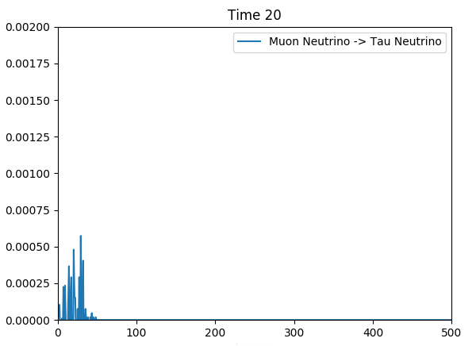

***Figure 2(a-j)****: Probability amplitude difference between propagating muon neutrino and tau neutrino wave packet. The vertical axes indicates probability difference for the wave packet and the horizontal one indicates physical length. All unit are rescaled for numerical convenience in accordance with experimental (physical) values.*

Each of these figures describes the difference in probability amplitudes of muon and tau neutrino wave packets propagating through space at a particular moment in their path. Since, each neutrino flavor is a different linear combination of the mass eigenstates, the probability difference can be reinterpreted as the inverse of transition probability in contrast of detecting neutrino flavor in detector. With this context lower probability difference between flavors of similarly normalized wave packets implies a high transition probability, thus a transition of flavor in detector.

It is apparent from the figures that the probability difference oscillates over time with a driving effect which signifies an oscillating transition probability with damping effect.

# **Decoherence:**

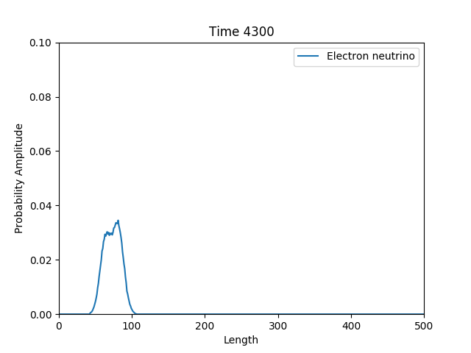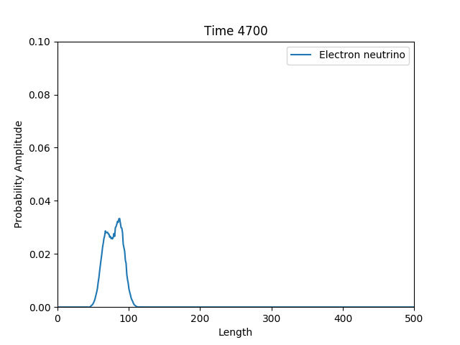

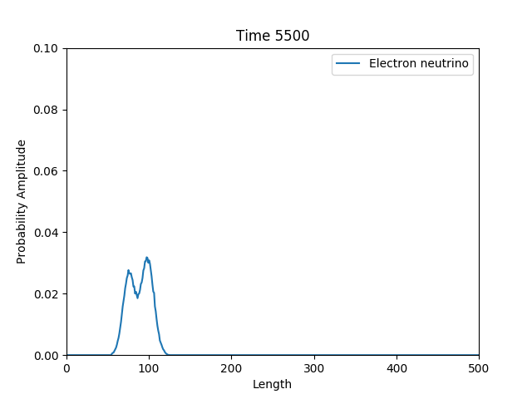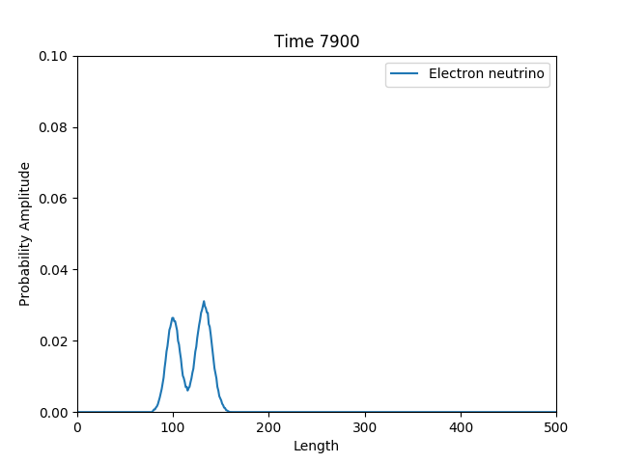

***Figure 2(a-j)****: Probability amplitude of electron neutrino wave packet. The vertical axes indicates probability amplitude for the wave packet and the horizontal one indicates physical length. All unit are rescaled for numerical convenience in accordance with experimental (physical) values*

It is found that over a certain length, flavor wave packets reach de-coherence in the sense that the mass eigenstates get separated in space which was analytically predicted, considering only quantum mechanical calculation based upon relativistic energy approximation. The coherent length from analytical calculation was matched with the rescaled value found from simulation and they appeared to be in harmony.

The transition probability of electron neutrino to other flavors occurs to be very low compared to other flavors of neutrinos because the lightest neutrino (electron neutrino in case of normal ordering in mass hierarchy) is the one with smallest mixing corresponding to greatest survival probability. (18) (19)

**Discussion and conclusion**

Neutrino oscillation corresponds to neutrino mass whereas standard model is inadequate to comprehend massive neutrino. The origin of neutrino mass generation is still unknown. In this work we did not go into the complexities of neutrino mass generation rather tried to visualize the phenomena of neutrino oscillation from an alternative formulation of quantum mechanics-Wigner formulation, which is analogous to Feynman's path integral formulation of quantum mechanics. (13) Conventional procedure to simulate neutrino oscillation by Monte Carlo method is performed by evaluating multidimensional integral of scattering matrix which can be obtained from Dyson series. (20) The other Monte Carlo methods like path integral Monte Carlo fails for evaluating real time evolution of quantum systems as they are based on imaginary time formulation. (21) (22) Wigner Monte Carlo in terms of singed particle formulation can be exploited for evolving quantum systems in real time. (16) In this work, we demonstrated neutrino flavor changing phenomena for tau and muon neutrino (for the fact that electron neutrino has the lowest transition probability) with PMNS matrix which conveys the fact that neutrino is indeed massive.

# **Acknowledgment**

We would like to thank Asst. Prof. Dr. Md. Enamul Hoque for his supervision and guidance throughout the project. We are also grateful to Prof. Dr. Syed Badiuzzaman Faruque and Lecturer Jaseer Ahmed for their valuable advice and assessment. Our special gratitude towards Prof. Dr. Jean Michel Sellier who provided us with effective and beneficial resources.

# **References**

1. *Neutrino Physics.* **Xing, Zhi-zhong.** s.l. : arXiv:1406.7739v1 [hep-ph] , 2014.

2. *Evidence for oscillation of atmospheric neutrinos.* **Fukuda, Y and Hayakawa, T and Ichihara, E and Inoue, K and Ishihara, K and Ishino, Hirokazu and Itow, Y and Kajita, T and Kameda, J and Kasuga, S and others.** s.l. : Physical Review Letters, 1998, Vol. 81.

3. *Direct Evidence for Neutrino Flavor Transformation from Neutral-Current Interactions in the Sudbury Neutrino Observatory.* **Ahmad, Q. R. and Allen, R. C. and Andersen, T. C. and D.Anglin, J. and Barton, J. C. and Beier, E. W. and Bercovitch, M. and Bigu, J. and Biller, S. D. and Black, R. A. and Blevis, I. and Boardman, R. J. and Boger, J. and Bonvin, E. and Boulay, M. G. and.** 1, s.l. : American Physical Society, 2002, Phys. Rev. Lett., Vol. 89.

4. *Evidence for neutrino oscillations i: Solar and reactor neutrinos.* **McDonald, AB.** s.l. : arXiv preprint nucl-ex/0412005, 2004.

5. *Neutrino oscillations and the seesaw origin of neutrino mass.* **Miranda, OG and Valle, JWF.** s.l. : Elsevier, 2016, Nuclear Physics B, Vol. 908.

6. *Neutrino physics.* **Kayser, Boris.** s.l. : arXiv preprint hep-ph/0506165, 2005.

7. *Remarks on the Unified Model of Elementary Particles.* **Maki, Ziro and Nakagawa, Masami and Sakata, Shoichi.** 1962, Progress of Theoretical Physics, Vol. 28, pp. 870-880.

8. *Erratum: Massive neutrinos and neutrino oscillations.* **Bilenky, SM and Petcov, ST.** s.l. : APS, 1988, Reviews of Modern Physics, Vol. 60.

9. *Neutrino oscillations: the rise of the PMNS paradigm.* **Giganti, Claudio and Lavignac, St{\'e}phane and Zito, Marco.** s.l. : Elsevier, 2018, Progress in Particle and Nuclear Physics, Vol. 98.

10. *Wave-packet treatment of reactor neutrino oscillation experiments and its implications on determining the neutrino mass hierarchy.* **Chan, Yat-Long and Chu, M-C and Tsui, Ka Ming and Wong, Chan Fai and Xu, Jianyi.** 6, s.l. : Springer, 2016, The European Physical Journal C, Vol. 76, p. 310.

11. *When do neutrinos really oscillate? Quantum mechanics of neutrino oscillations.* **Giunti, Carlo and Kim, Chung W and Lee, UW.** s.l. : Physical Review D, 1991, Vol. 44.

12. *Coherence of neutrino oscillations in the wave packet approach.* **Giunti, Carlo and Kim, Chung W.** s.l. : Physical Review D, 1998, Vol. 58.

13. *On a quasiprobability distribution in quantum mechanics.* **Wigner, EP.** s.l. : Phys. Rev, 1932, Vol. 40.

14. *An introduction to applied quantum mechanics in the Wigner Monte Carlo formalism.* **Sellier, JM and Nedjalkov, Mihail and Dimov, Ivan.** s.l. : Physics Reports, 2015, Vol. 577.

15. *A benchmark study of the Wigner Monte Carlo method.* **Sellier, Jean Michel and Nedjalkov, Mihail and Dimov, Ivan and Selberherr, Siegfried.** 1, s.l. : Walter de Gruyter GmbH, 2014, Vol. 20.

16. *A signed particle formulation of non-relativistic quantum mechanics.* **Sellier, Jean Michel.** s.l. : Journal of Computational Physics, 2015, Vol. 297, pp. 254--265.

17. *Wave packet description of neutrino oscillation in a progenitor star supernova environment.* **Torres, FR and Guzzo, MM.** 4, s.l. : SciELO Brasil, 2007, Brazilian Journal of Physics, Vol. 37, pp. 1273--1278.

18. *Neutrino mass ordering from oscillations and beyond: 2018 status and future prospects.* **de Salas, Pablo F and Gariazzo, Stefano and Mena, Olga and Ternes, Christoph A and T{\'o}rtola, Mariam.** 2018, arXiv preprint arXiv:1806.11051.

19. *Phenomenology of neutrino mixing in vacuum and matter.* **Upadhyay, A and Batra, M.** s.l. : Hindawi Publishing Corporation, 2013, ISRN High Energy Physics, Vol. 2013.

20. *Monte Carlo neutrino oscillations.* **Kneller, James P and McLaughlin, Gail C.** 5, s.l. : APS, 2006, Physical Review D, Vol. 73, p. 056003.

21. *Introduction to the diffusion Monte Carlo method.* **Kosztin, Ioan and Faber, Byron and Schulten, Klaus.** 5, s.l. : AAPT, 1996, American Journal of Physics, Vol. 64, pp. 633--644.

22. *On path integral Monte Carlo simulations.* **Herman, MF and Bruskin, EJ and Berne, BJ.** 10, s.l. : AIP, 1982, The Journal of Chemical Physics, Vol. 76, pp. 5150--5155.

23. **Sellier, Jean Michel.** Wigner and Signed Particle Formalisms for Quantum Simulations. *nano-archimedes.* [Online] http://www.nano-archimedes.com/.

24. **Ahmed, Shakir.** Neutrino Oscillation. *Github.* [Online] https://github.com/ravenwit/Neutrino_Oscillation.